**Audio Processing**

**Ex02 – Report**

Student: Anh Huy Bui

ID: 293257

**Problem 1:**

c.

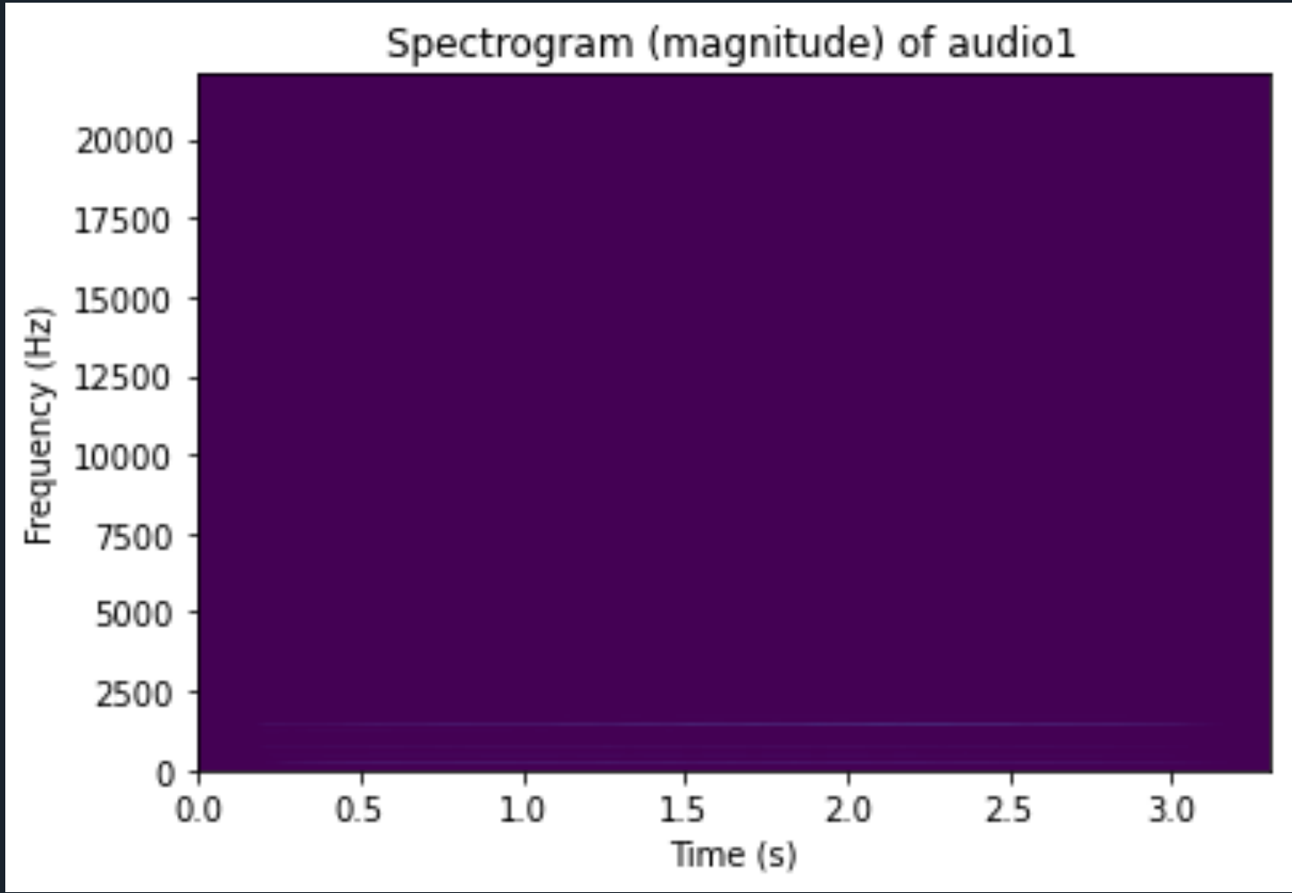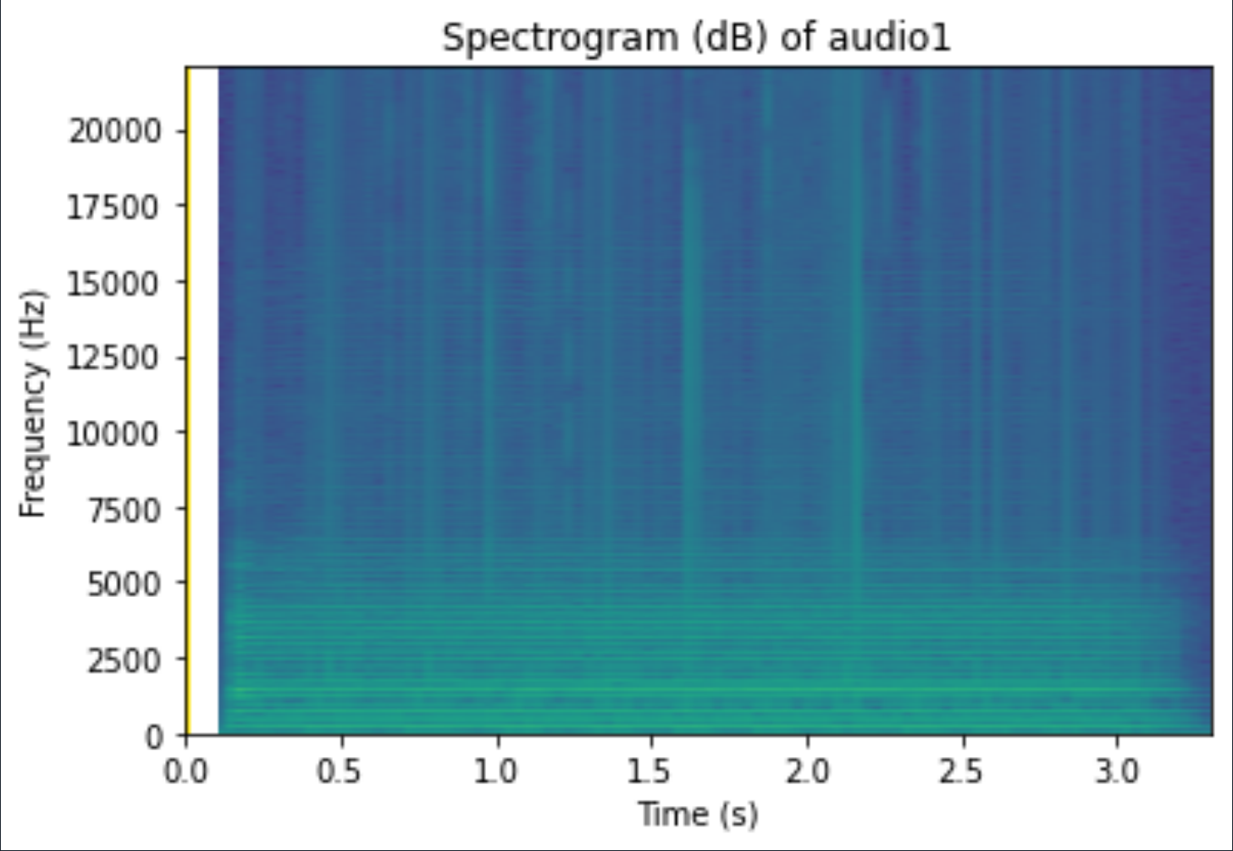

It can be seen form the graphs that spectrogram in logarithm scale is much easier to observe. This is because the magnitude of origin signal is too low, while logarithm scale is a relatively scale based on the relation among all frames of the audio.

**Problem 2:**



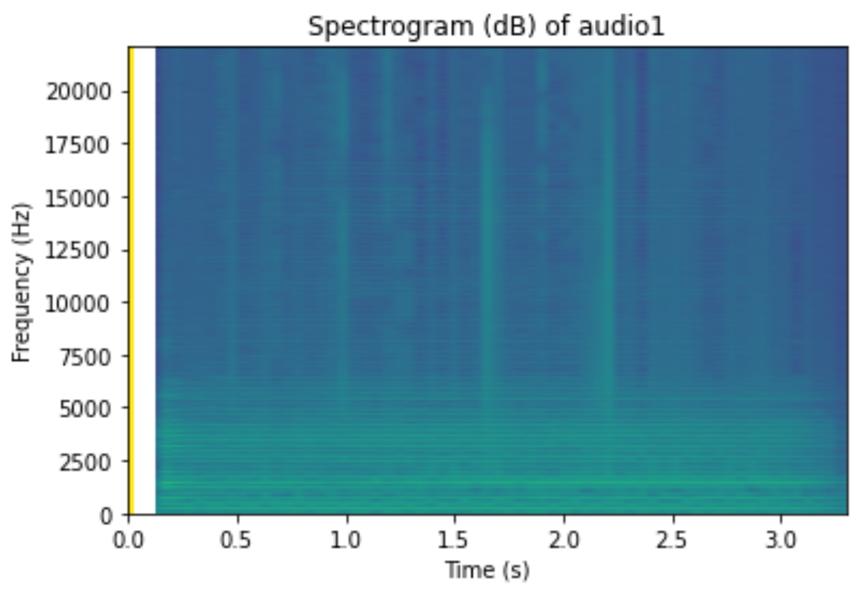

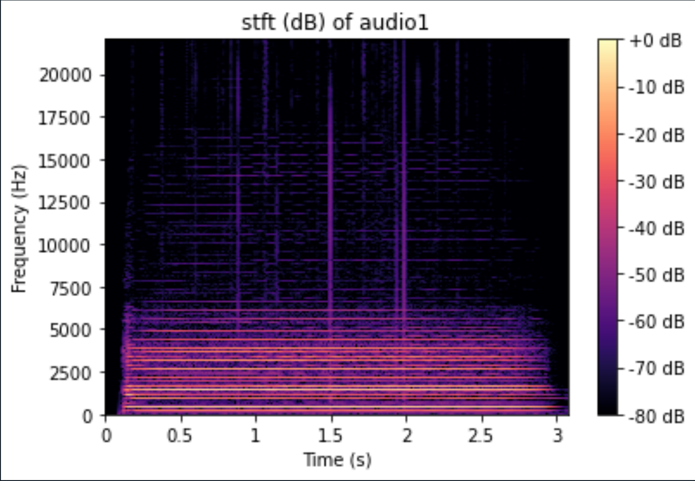

I use librosa.stft to calculate. Both are configured with a window length as 100ms. However, librosa Fs is default 22050, so I did some calculation to get correct frame length.

As a brief look, the 2 graphs display quite similarly, although there is a blank column in my own spectrogram. This is because I did not solve the log10(0) problem. Beside that, it seems ok in my opinion.



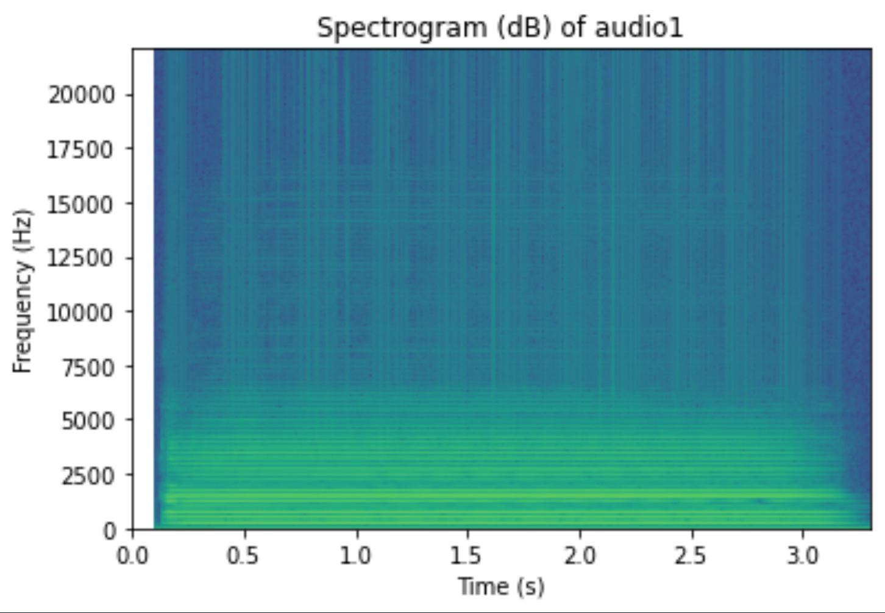

Figure 2b.1. Spectrogram of audio1 with window length = 16ms

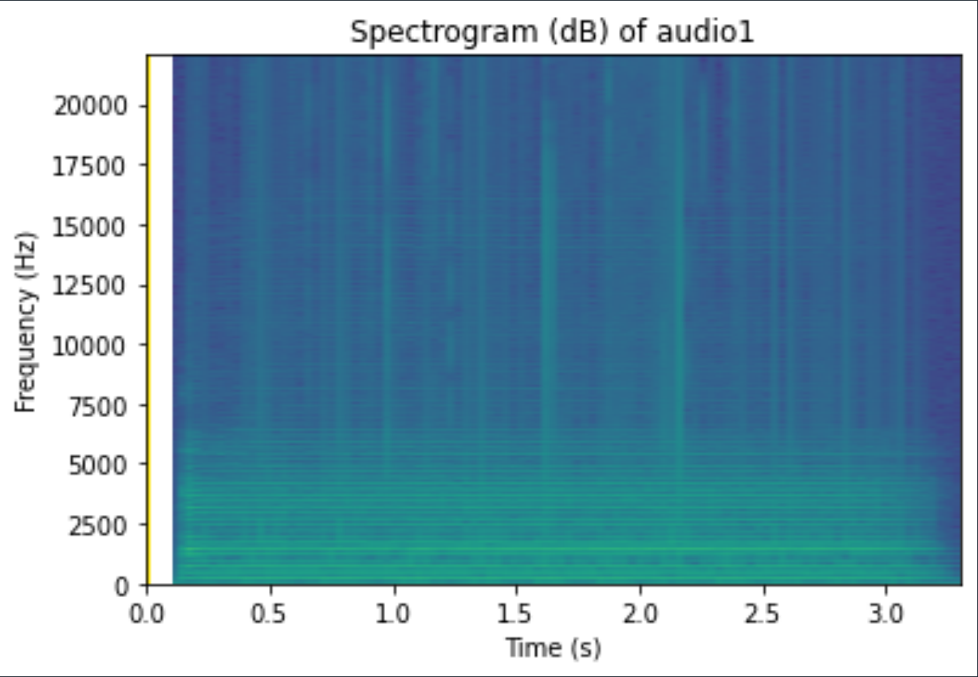

Figure 2b.2. Spectrogram of audio1 with window length = 64ms

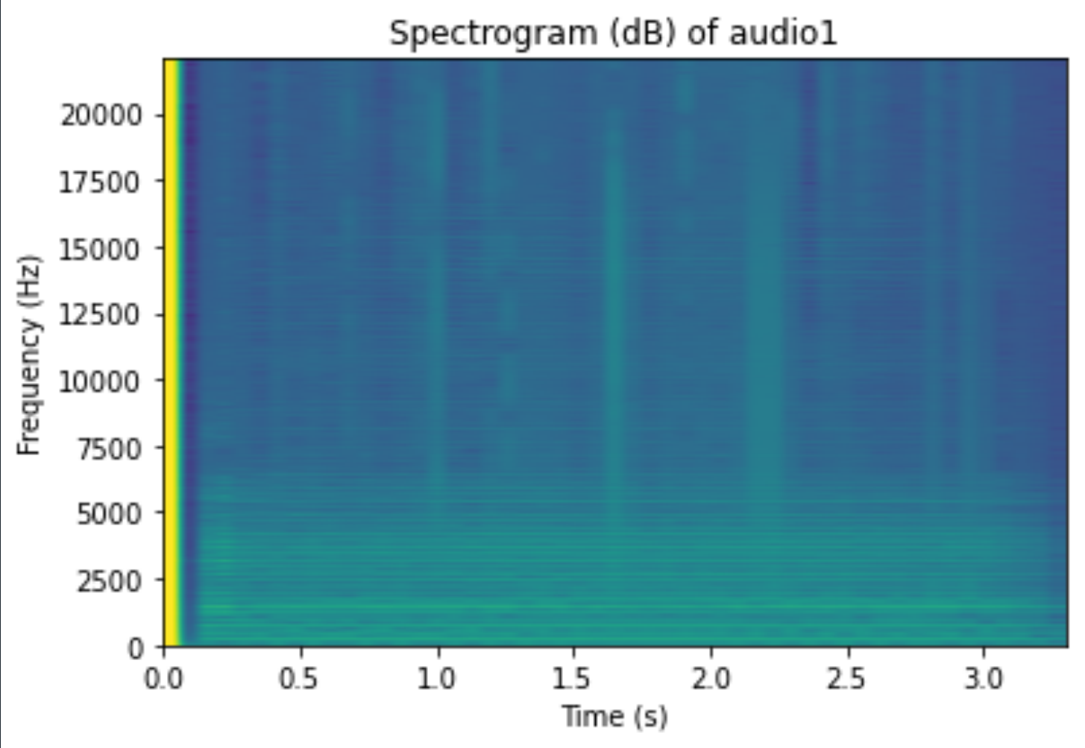

Figure 2b.3. Spectrogram of audio1 with window length = 128ms

1. From my observation, spectrogram window length 128 has low resolution in time axis, while 16ms one is better.

Because every segment of 16ms one is much more detailed. However, spectrogram window length 16ms lost some data in frequency. In my opinion capturing a 16ms segment (or 62.5Hz in other words) may cause data lost in some low frequency.

**All output figures from code:** *(Signal – Window length)*

**Audio1 - 16ms**

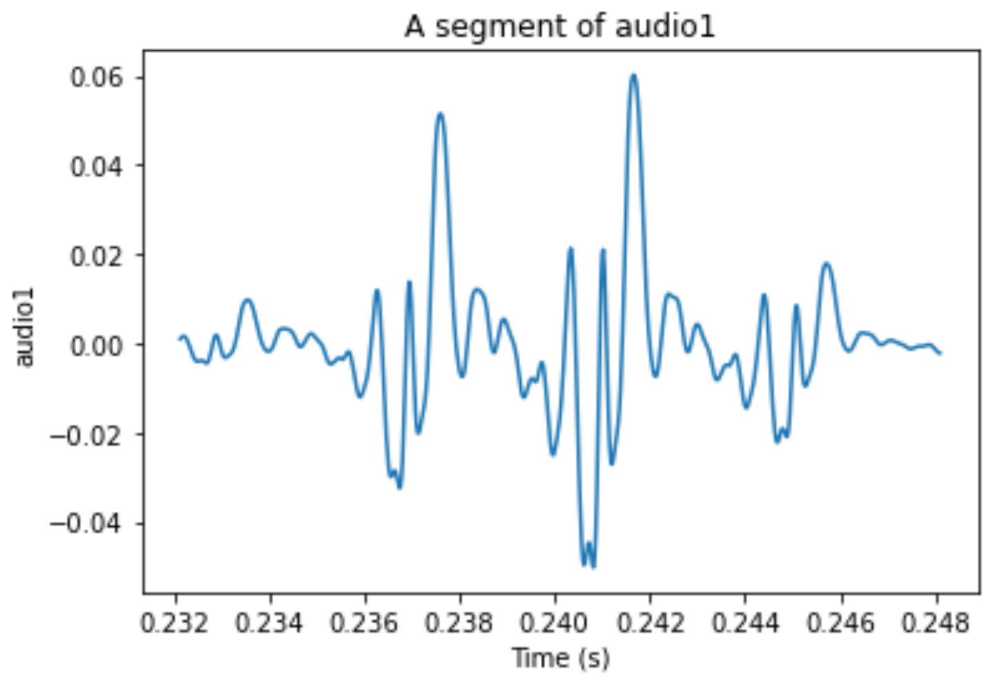

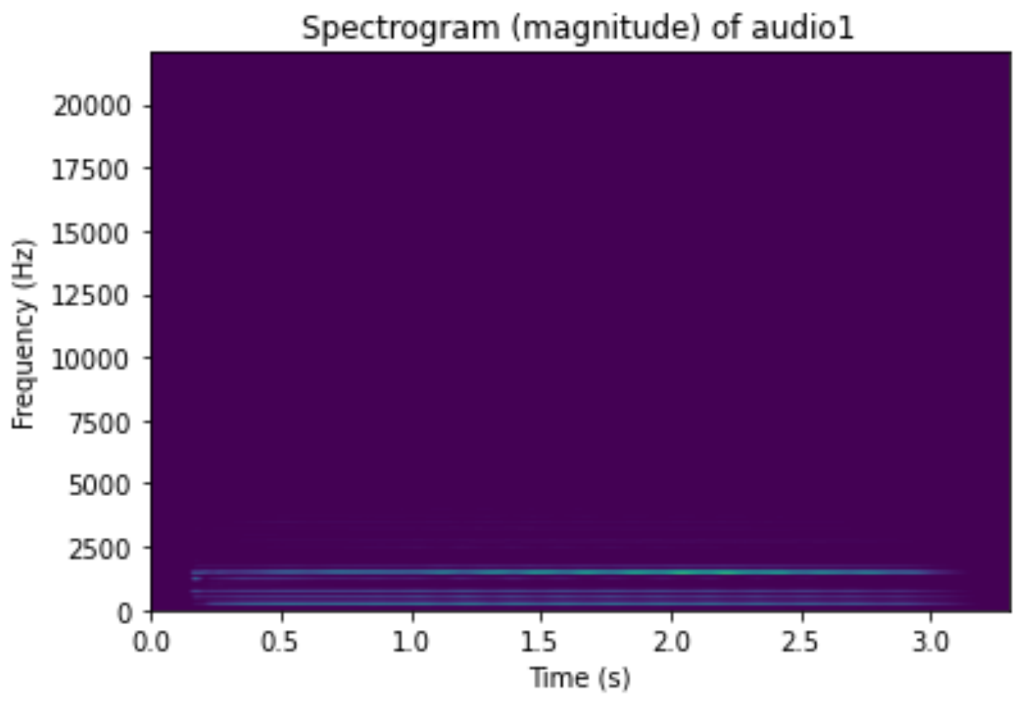

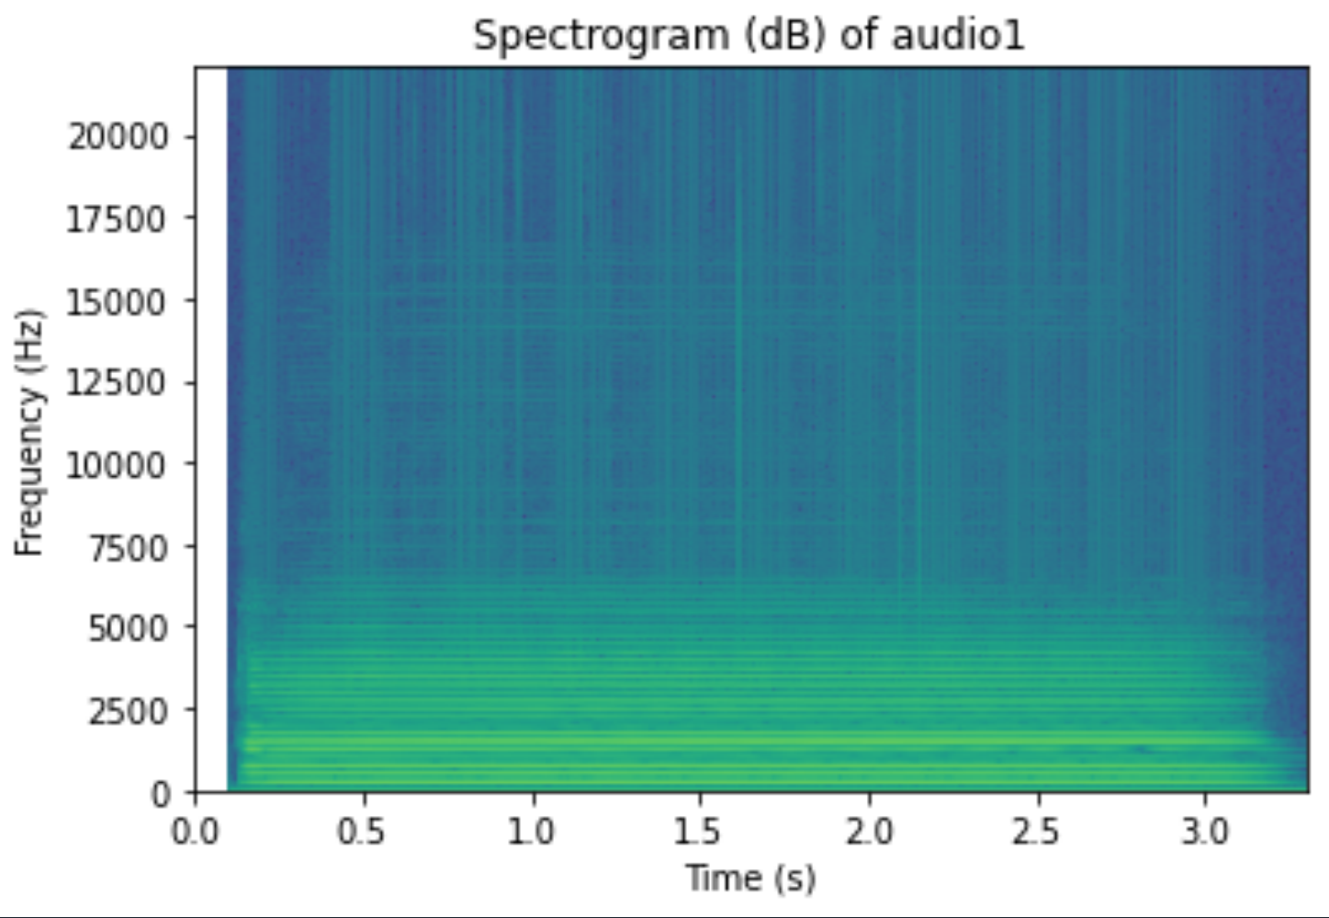

**Audio1 - 64ms**

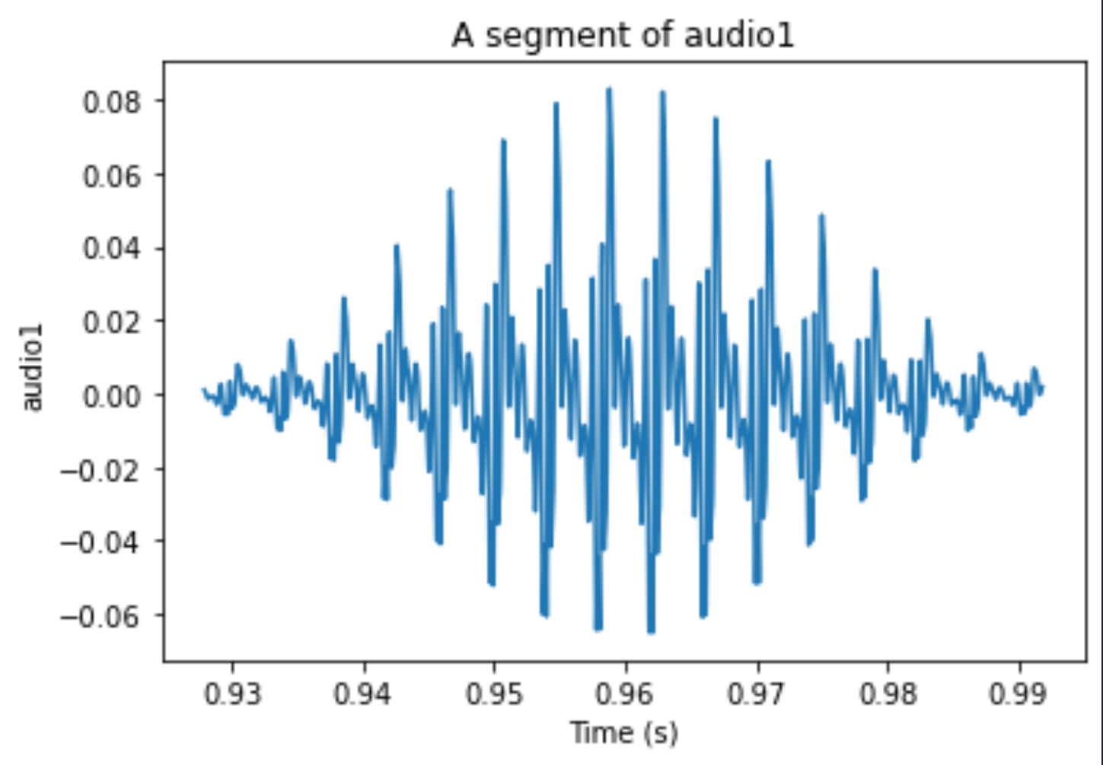

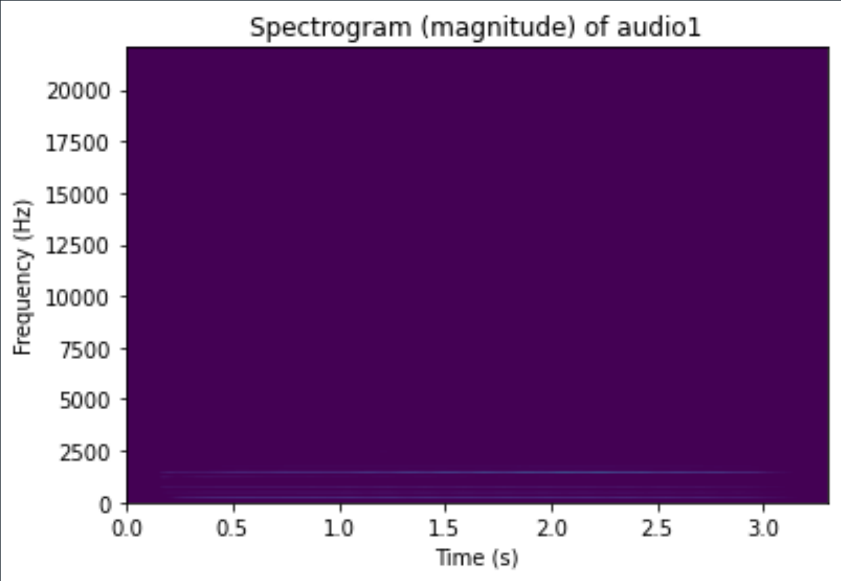

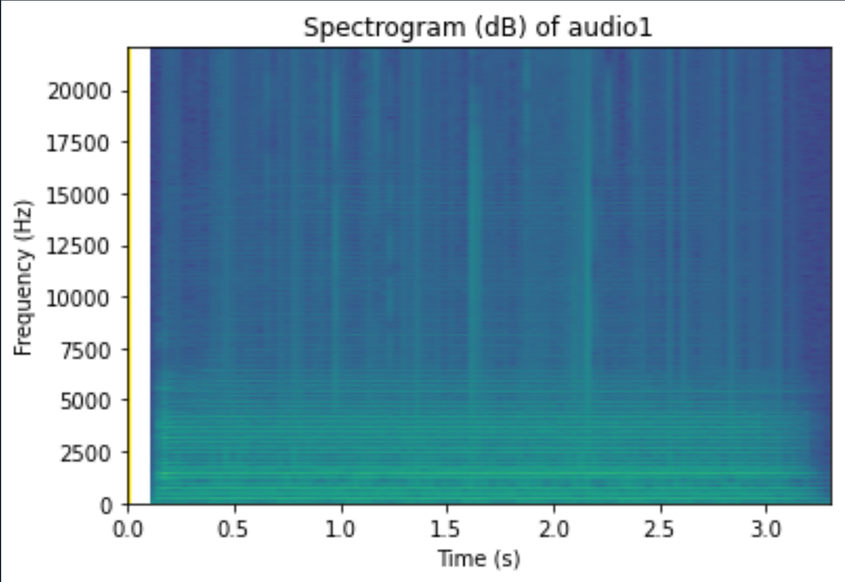

**Audio1 - 128ms**

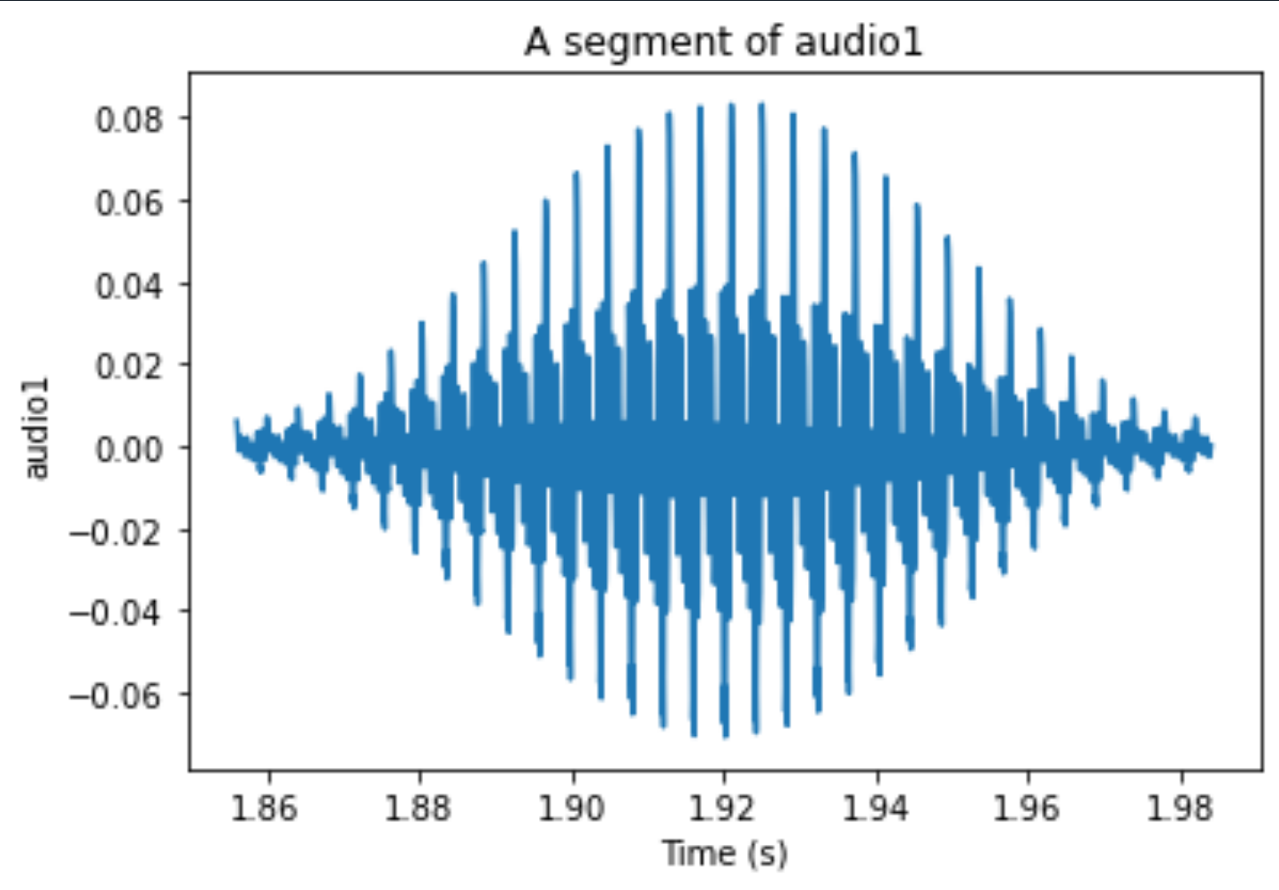

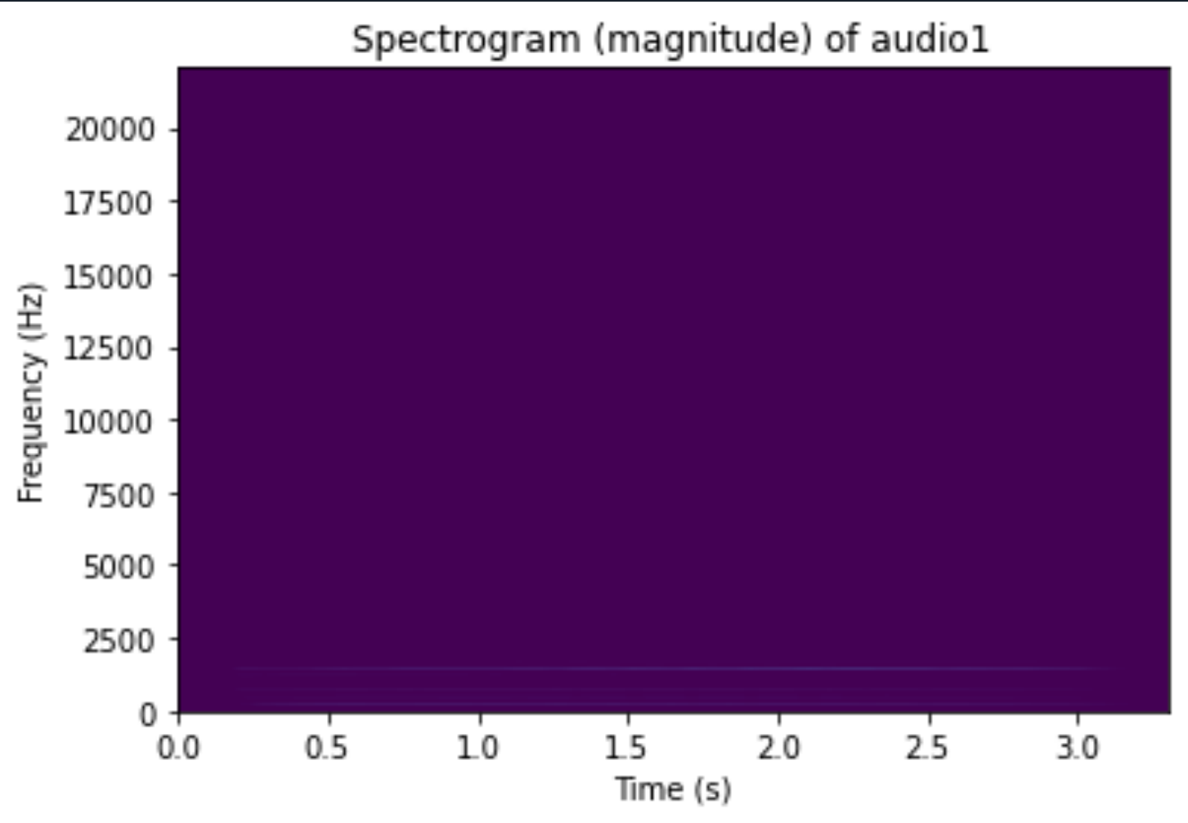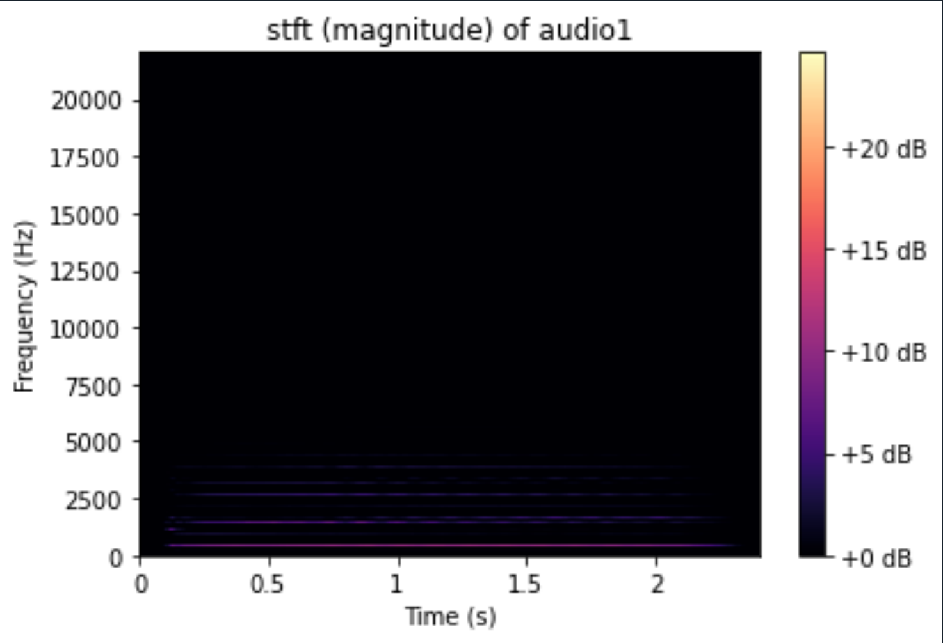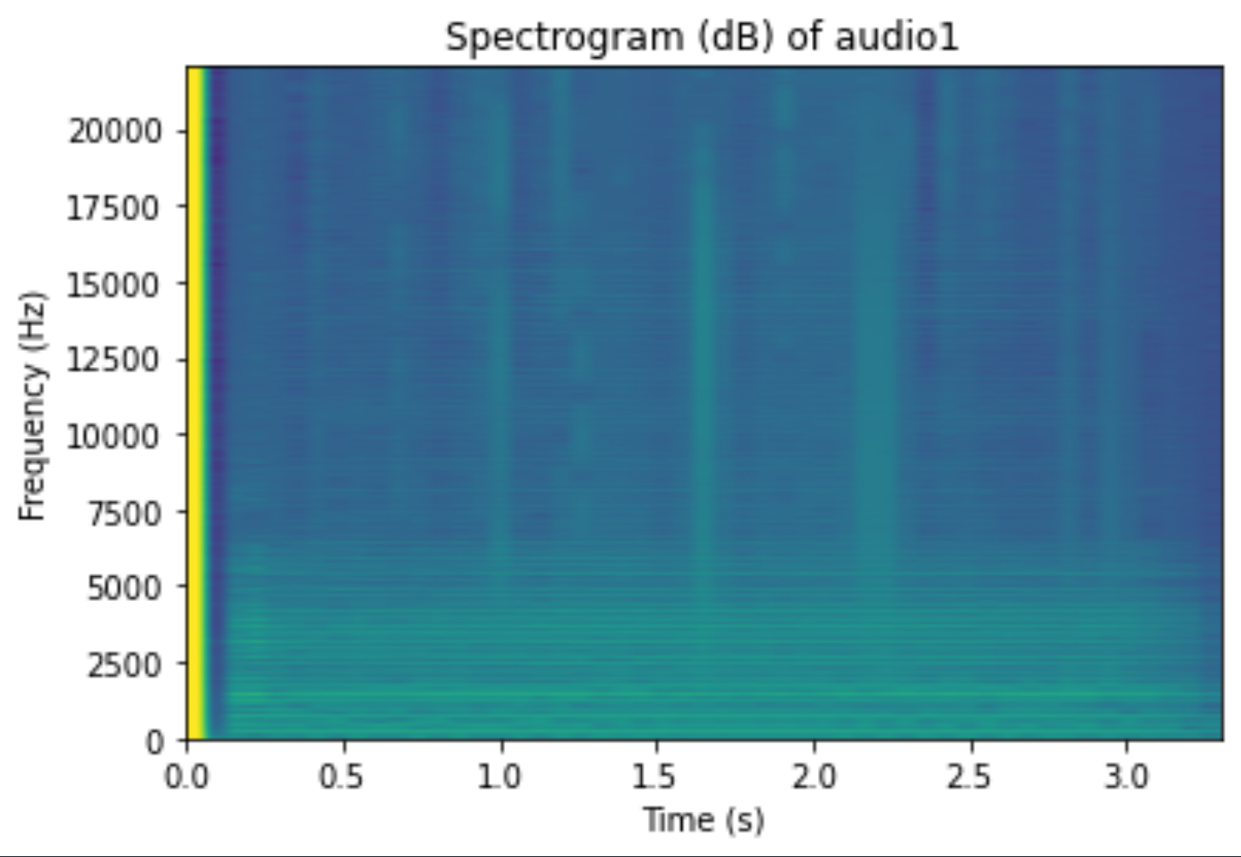

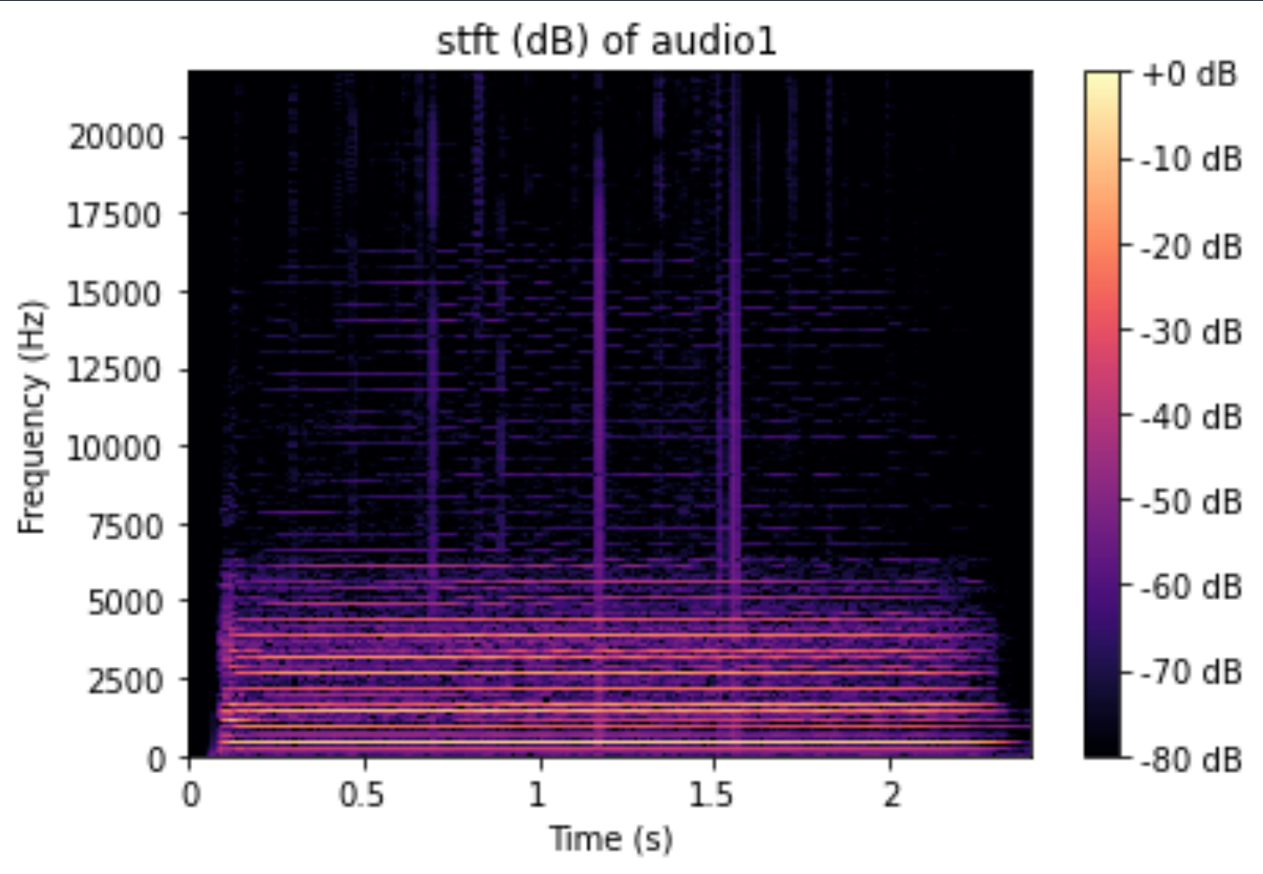

**Audio2 - 100ms**

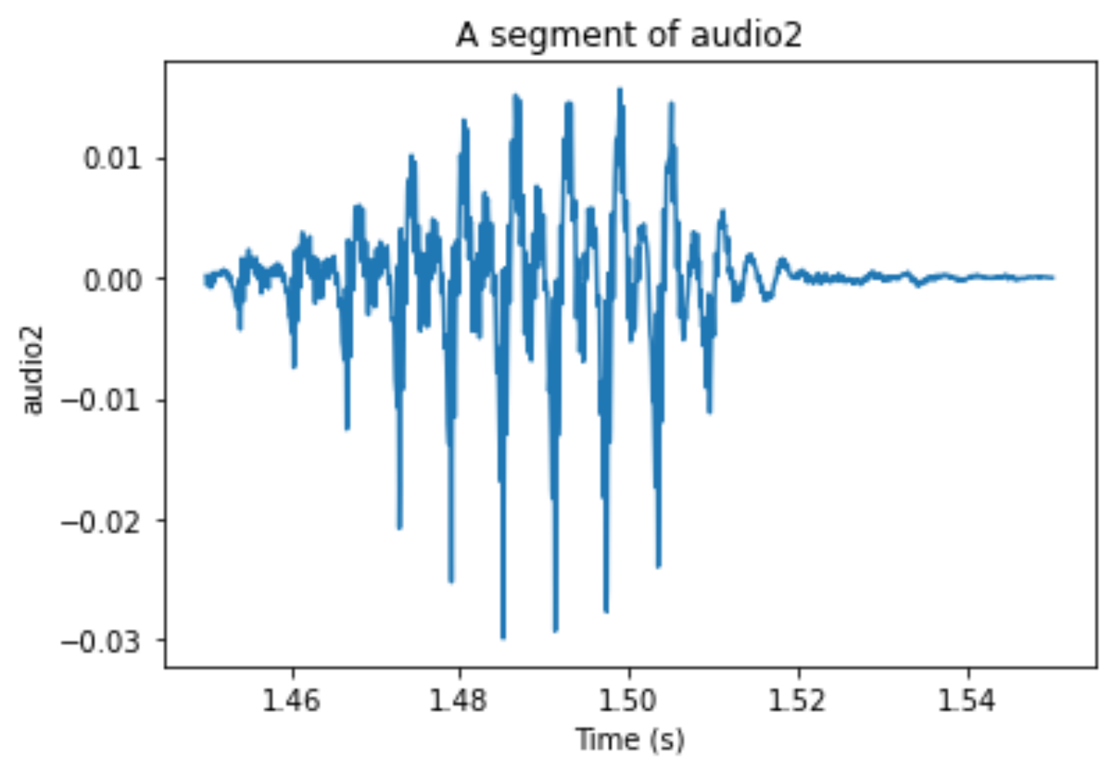

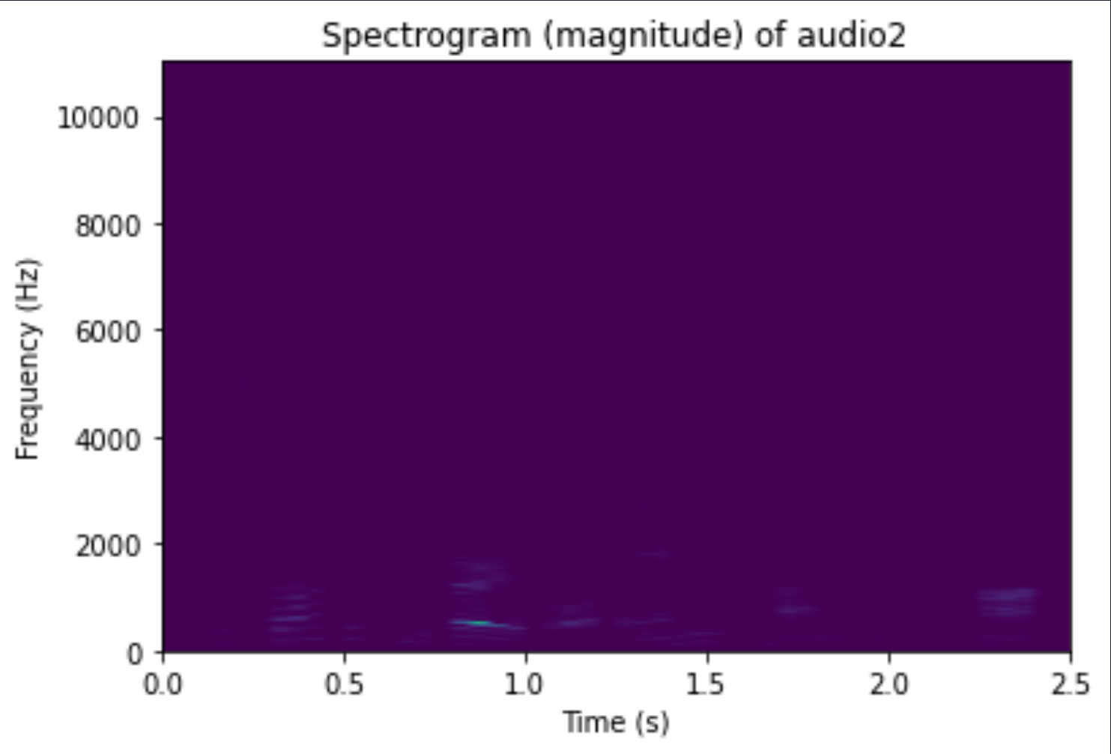

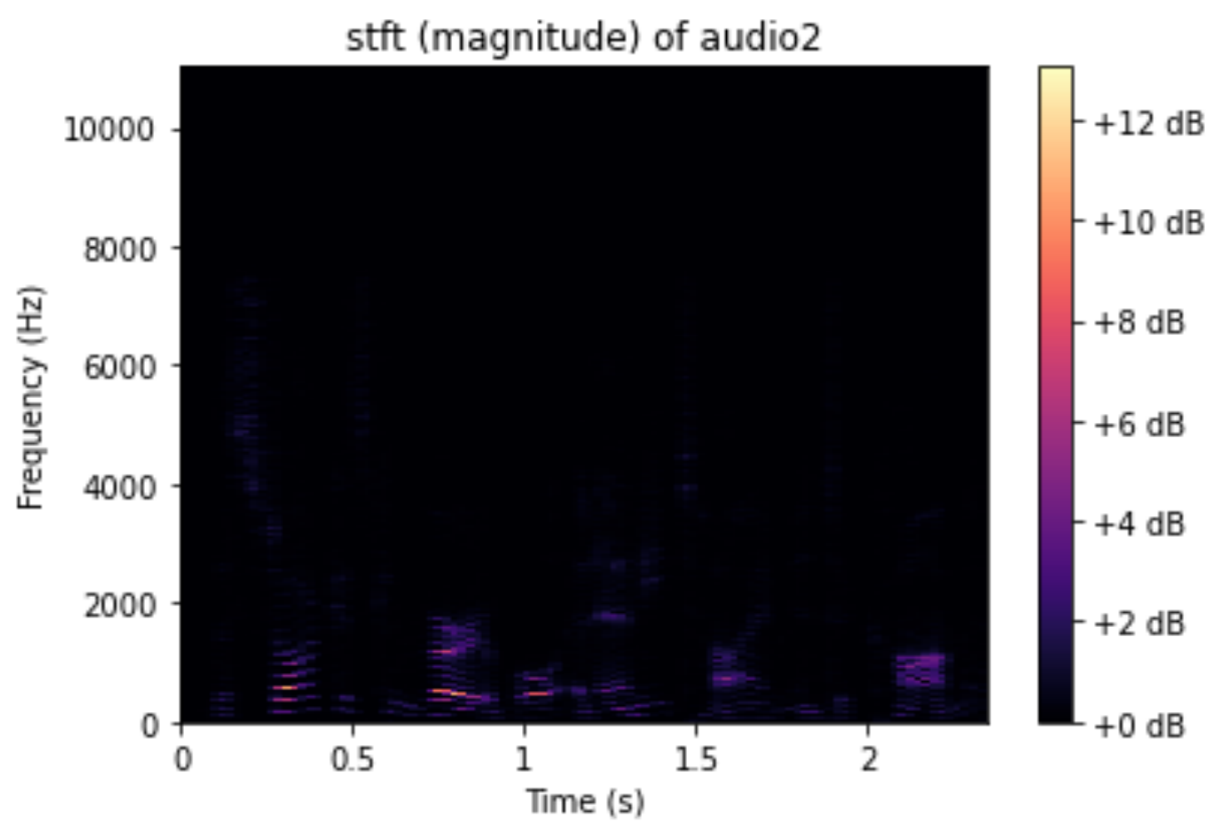

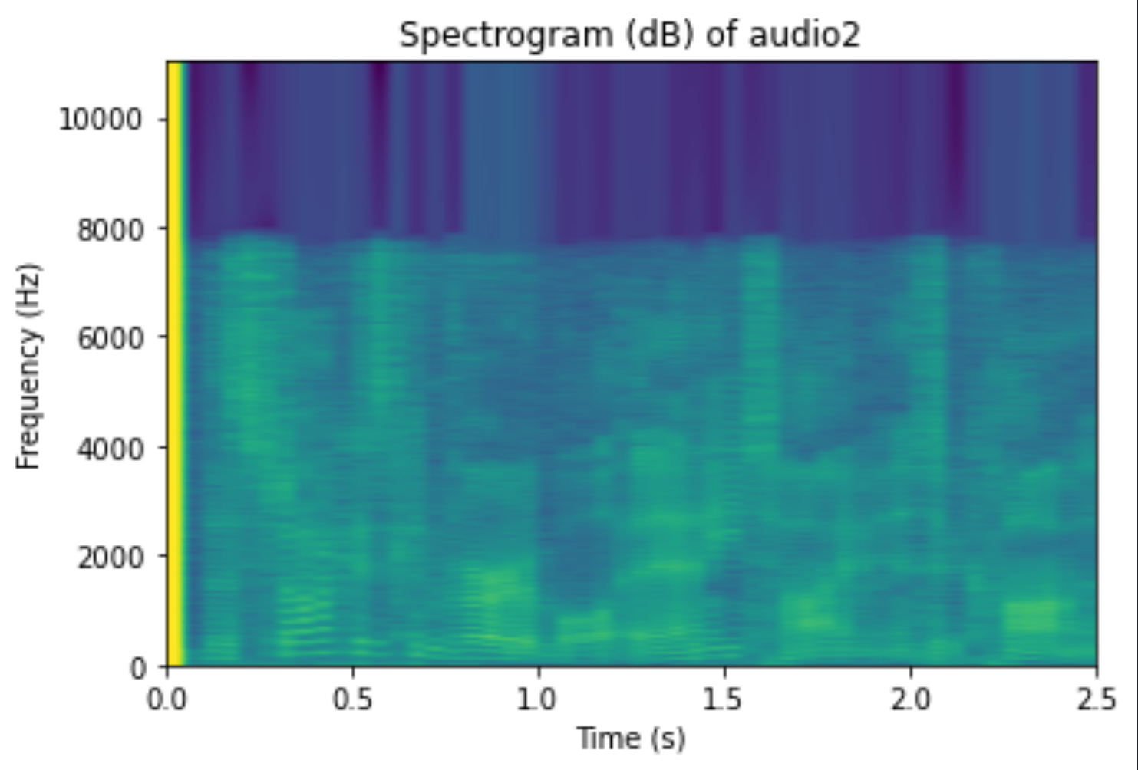

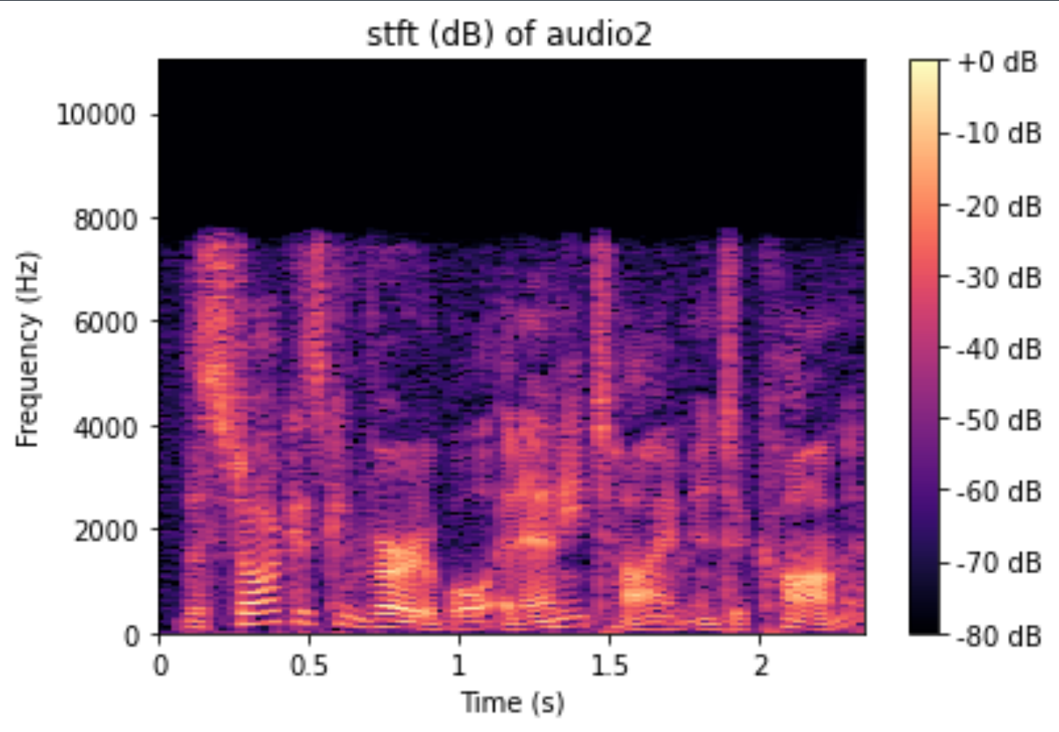

**Sinusoids - 100ms**

